**Documentation**

This is an internal documentation of my portfolio. This project is created using Vite + React. Majority of the language used is html, css and react syntax.

An image folder was created as well which includes all of the images referenced in the project.

**Home Page**

The home.jsx file contains the <section> tag that wraps the <h1>,<p> and <a> tag . Each tage which it’s unique id if necessary. The css styling is done in the index.css file. There are 2 ways to navigate to the About page from the home page(underlined with red in the second image below).

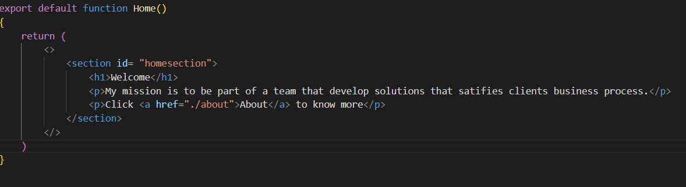

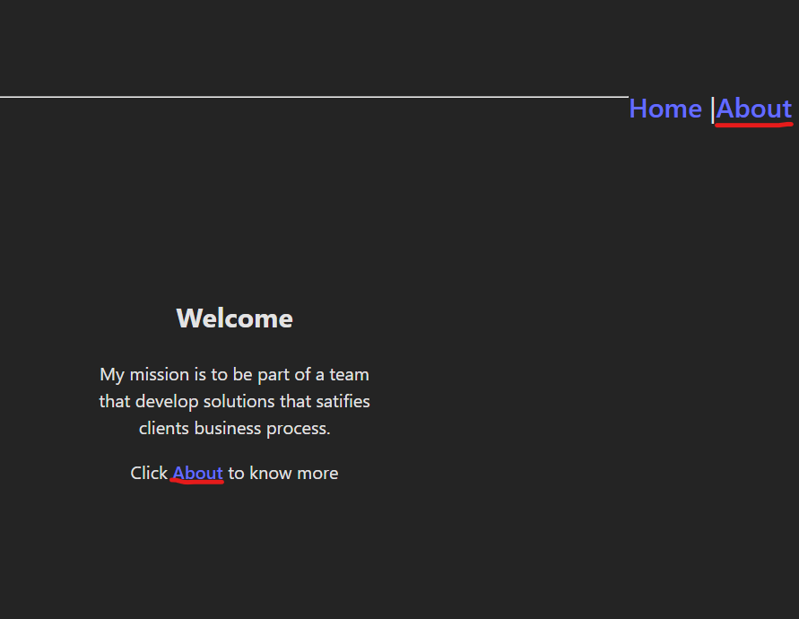

**About Page**

The about page has a main <div> tag that holds all the other tags. The css styling is done in the about.css file which is imported in the about.jsx file as seen from the screenshot. It also has a link to the resume(underlined in red) that redirects out of the app.

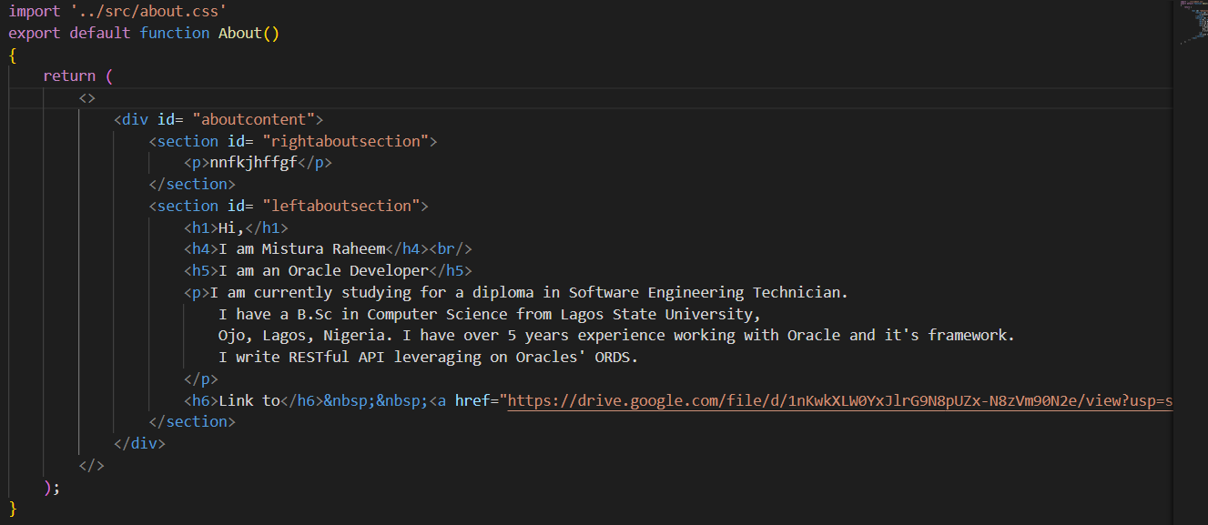

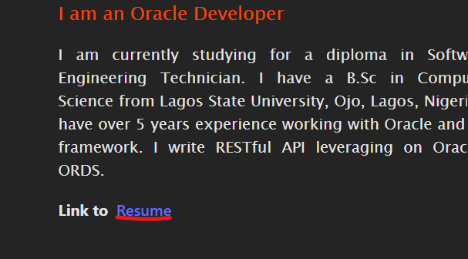

**Service Page**

The about page has a main <div> tag that holds all the other<p> tags. The css styling is done in the service.css file which is imported in the service.jsx file as seen from the screenshot.

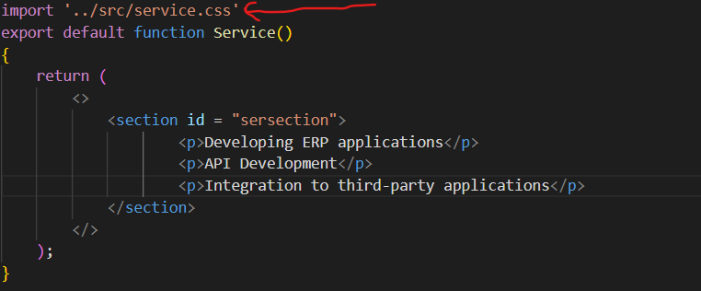

**Project Page**

The about page has a main <div> tag that holds all the other tags. The css styling is done in the project.css file which is imported in the project.jsx file as seen from the screenshot.

**Contact Page**

The about page has a main <form> tag that holds all the other tags. The css styling is done in the contact.css file which is imported in the contact.jsx file as seen from the screenshot. This is a basic form to provide basic information when trying to reach out.

